
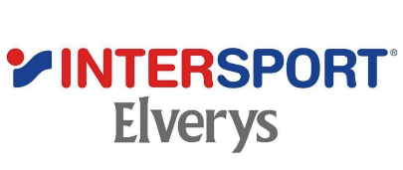

Innovation Challenge
‘These Boots are Made for Recycling!’
According to a recent article in the Irish Times, 90% of trainers end up in incineration or landfill where components can last 1,000 years. Intersport Elverys, together with the Innovation Exchange, are looking for a solution to lessen this needless waste.
Intersport Elverys will be offering a return facility in-store, coupled with a potential incentive scheme for old running shoes/trainers.
The challenge is centred around the final solution of the shoes – where do they go after Intersport Elverys has received a return of the product, whilst always being conscious of a circular economy? And in what form are they returned to the economy - maybe re-processed into playground surfaces or otherwise?
Consideration can be given to a possible incentive scheme to encourage consumers to deposit their used trainers for recycling.
If you have an idea and a solution that can solve this problem as a total fulfilment offering, please forward a proposal using the following template:
WORD DOCUMENT with the following items addressed:
- What is the problem you will solve – 100 words
- What is your solution – 100 words
- What is the upside to Intersport Elverys – 100 words
- Summary – 50 words
Please do not include images or logos in the submission a simple word document is all we require.
All submissions to be sent to info@theinnovationexchange.ie by COB Friday 4th August 2023. We hope that there are good, innovative, solutions available and look forward to hearing from you.

Let’s try to lessen the waste!

