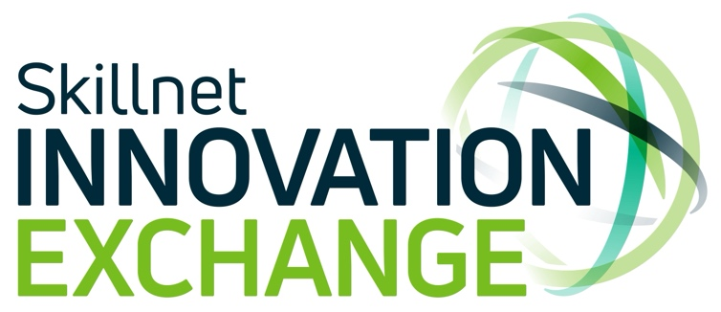

Skillnet Innovation Exchange Expands into Northwest

Dublin, October 18, 2024: Skillnet Innovation Exchange, the initiative that connects large businesses facing innovation challenges with SMEs that can fast track the solutions, has announced an expansion into the northwest region through its west regional partner, Platform94, as part of its continuing nationwide expansion.

Platform94 will bring the benefits of Skillnet Innovation Exchange to businesses in Donegal, Sligo and Leitrim. The partnership will offer ambitious and innovative SMEs the opportunity to get connected with large businesses looking to access digital transformation solutions.

Attending today’s launch in Sligo’s AIM Centre, Dara Calleary TD, Minister of State for Trade Promotion, Digital and Company Regulation, said: “I’m delighted to welcome Skillnet Innovation Exchange to Sligo, Donegal and Leitrim and very pleased that the benefits offered by the initiative can now be easily accessed by SMEs in the northwest. Congratulations to Platform94 and Skillnet Innovation Exchange for making this happen and showing what can be achieved by positive collaboration.”
The nationwide expansion of the programme offers more SMEs access to a wide range of benefits, including access to a readymade sales pipeline, upskilling and collaboration opportunities with large corporations. To date, the Innovation Exchange has facilitated the delivery of 50 innovation challenges to its SME member base. Corporate members of the Innovation Exchange, which now number over 40, include some of Ireland’s leading companies including Ernst & Young, Hilton Foods, BWG, Coolmore Stud, ESB, Ryanair, An Post and many more.
Paul Healy, Skillnet Ireland Chief Executive, said: “Skillnet Ireland is delighted to announce the latest expansion of Skillnet Innovation Exchange in the northwest region. This expansion into Sligo, Donegal and Leitrim will create vital opportunities for SMEs to widen their business horizons and engage with larger corporations on pressing innovation challanges. Through this collaboration, large domestic and multinational companies will benefit greatly from access to innovative homegrown SMEs”.

Platform94, which helps ambitious technology businesses in the west of Ireland and beyond to scale internationally, was the first enterprise hub to become a regional partner of the Innovation Exchange in 2023. Other Skillnet Innovation Exchange regional partners include the Ludgate Hub in Cork, The Mill in Drogheda, RDI Hub in Kerry and GreenTech HQ in Enniscorthy.
Conor Carmody, Director, Skillnet Innovation Exchange, said: “Skillnet Innovation Exchange’s regional expansion throughout Ireland has afforded many SMEs the unique opportunity to collaborate with large corporates, bridging the innovation divide and strengthening the Irish business ecosystem. We are excited to continue our collaboration with Platform94 and to cultivate new, impactful relationships with businesses in the northwest. We especially look forward to highlighting the exceptional talent within northwest companies and supporting their growth as they scale their businesses”.

Marie Donnellan, CEO, Platform94 said, “At Platform94, we’ve always maintained a regional approach in our work with innovative and scaling businesses throughout the west and northwest of Ireland.
We’ve focused on fostering a strong spirit of collaboration across both the west and northwest region. This extended partnership will enable us to offer even greater support to these businesses and the broader scaling ecosystem in the West/Northwest.”

<END>

About Skillnet Innovation Exchange
Skillnet Innovation Exchange is where businesses facing digital transformation challenges are connected with innovative solutions providers with the talent to help them achieve their ambitions. Large corporations get access to Ireland’s most talented solutions providers to accelerate digital transformation. Scaling technology companies get an instant sales pipeline as well as access to key decision makers, market intelligence and the capability to sell to large corporates. To learn more, visit www.theinnovationexchange.ie

About Skillnet Ireland
Skillnet Ireland is the national talent development agency of the Government of Ireland, responsible for advancing the competitiveness, productivity, and innovation of Irish businesses through enterprise-led talent development. Skillnet Ireland partners with 57 industry bodies, supporting over 26,600 businesses and more than 97,700 trainees annually, through its 70 Skillnet Business Networks and National Initiatives - Skillnet Climate Ready Academy, Skillnet Innovation Exchange, Skillnet MMC Accelerate and MentorsWork - across most sectors and all regions in Ireland.

Skillnet Ireland is funded from the National Training Fund through the Department of Further and Higher Education, Research, Innovation and Science.
To learn more about Skillnet Ireland visit: www.skillnetireland.ie
Skillnet Business Network search tool: https://www.skillnetireland.ie/our-networks/
Facebook: @SkillnetIreland
Twitter: @SkillnetIreland
LinkedIn: www.linkedin.com/company/skillnetireland

About Platform94: https://platform94.com/

For further information or interview requests, please contact:
Oonagh Fox, Skillnet Innovation Exchange
0878554406
oonagh@theinnovationexchange.ie

Noreen Conway, Platform94
0861973638
noreen.conway@platform94.com

