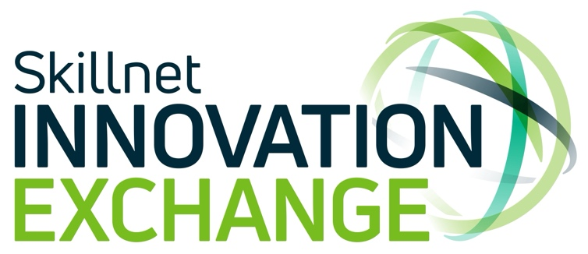

Skillnet Innovation Exchange Expands into Limerick

Dublin, October 11, 2024: Skillnet Innovation Exchange, the initiative that connects large businesses facing innovation challenges with SMEs that can fast track the solutions, has announced an expansion into the southwest region through its regional partner, RDI Hub, as part of its continuing nationwide expansion.

RDI Hub and Innovate Limerick will join forces to bring the benefits of Skillnet Innovation Exchange to businesses in Limerick city and county. The partnership will offer ambitious and innovative SMEs the opportunity to get connected with large companies looking to access digital transformation solutions.

Attending today’s launch in Limerick’s Engine Collaboration Centre, Patrick O’Donovan TD, Minister for Further and Higher Education, Research, Innovation and Science, said: “I’m delighted that Skillnet Innovation Exchange is extending its reach and influence to Limerick and in doing so, is contributing to the competitiveness of companies in the region. Now, through Innovate Limerick, SMEs in the southwest can avail of the very real benefits Skillnet Innovation Exchange has to offer including upskilling, networking and access to business opportunities”.
The nationwide expansion of the programme offers more SMEs access to a wide range of benefits, including access to a readymade sales pipeline, upskilling and collaboration opportunities with large corporations. To date, the Innovation Exchange has facilitated the delivery of 50 innovation challenges to its SME member base. Corporate members of the Innovation Exchange, which now number over 40, include some of Ireland’s leading companies including EY, Hilton Foods, BWG, Coolmore Stud, ESB, Ryanair, An Post, and many more.
Paul Healy, Skillnet Ireland Chief Executive, said: “Skillnet Ireland is pleased to announce the latest expansion of Skillnet Innovation Exchange, this time in the Limerick region. The programme is offering much coveted opportunities for SMEs to expand their business horizons and engage with larger corporations. The Skillnet Innovation Exchange is also delivering substantial commercial solutions to domestic and multinational corporations that are engaged with the programme, and benefiting greatly from the creativity and innovation of our home-grown SMEs."

Other Skillnet Innovation Exchange regional partners include the Ludgate Hub in Cork, The Mill in Drogheda, Platform 94 in Galway and GreenTech HQ in Enniscorthy.
Conor Carmody, Director, Skillnet Innovation Exchange, said: “Skillnet Innovation Exchange’s regional expansion throughout Ireland has afforded many SMEs the unique opportunity to collaborate with large corporates, bridging the innovation divide and strengthening the Irish business ecosystem. We are excited to continue our collaboration with RDI Hub and to cultivate new, impactful relationships with businesses in the southwest. We especially look forward to highlighting the exceptional talent within companies and supporting their growth as they scale their businesses”.

Megan Daly-Tyrell, Business Development Manager, RDI Hub “‘The ethos at the RDI Hub is all about making connections for start-ups, scale-ups, SMEs, corporates and enterprises to create, digitalise, innovate and scale businesses. To this end, the Innovation Exchange is a perfect partnership for us as it supports our key focus which is creating new jobs, products and services in the southwest. RDI Hub is delighted to partner with Innovate Limerick to bring the benefits of Skillnet Innovation Exchange to businesses in Limerick city and county”.

Dennis Barry, CEO Innovate Limerick: "We are delighted to host the Skillnet Innovation Exchange launch here at the Engine. Innovate Limerick is synonymous with expanding and furthering the local ecosystem through collaboration and partnerships in all sectors. We are looking forward to partnering with the RDI Hub and expanding the Skillnet Innovation Exchange program to Limerick”.

<END>

About Skillnet Innovation Exchange
Skillnet Innovation Exchange is where businesses facing digital transformation challenges are connected with innovative solutions providers with the talent to help them achieve their ambitions. Large corporations get access to Ireland’s most talented solutions providers to accelerate digital transformation. Scaling technology companies get an instant sales pipeline as well as access to key decision makers, market intelligence and the capability to sell to large corporates. To learn more, visit www.theinnovationexchange.ie
About Skillnet Ireland

Skillnet Ireland is the national talent development agency of the Government of Ireland, responsible for advancing the competitiveness, productivity, and innovation of Irish businesses through enterprise-led talent development. Skillnet Ireland partners with 57 industry bodies, supporting over 26,600 businesses and more than 97,700 trainees annually, through its 70 Skillnet Business Networks and three National Initiatives - Skillnet Climate Ready Academy, Skillnet Innovation Exchange and MentorsWork - across most sectors and all regions in Ireland.

Skillnet Ireland is funded from the National Training Fund through the Department of Further and Higher Education, Research, Innovation and Science.

To learn more about Skillnet Ireland visit www.skillnetireland.ie
Skillnet Business Network search tool: https://www.skillnetireland.ie/our-networks/

Facebook: @SkillnetIreland
Twitter: @SkillnetIreland
LinkedIn: www.linkedin.com/company/skillnetireland

For further information or interview requests, please contact:
Oonagh Fox
0878554406
oonagh@theinnovationexchange.ie

